Dolan Jenner Fiber-Lite 180光纤照明

Fiber-Lite 180 Illuminator
Classic 150 Watt Illuminator

Durable and quiet with the lowest possible vibration levels
Compatible with all Fiber-Light standard and custom fiber optic light guides

产品规格：
灯泡：EKE,21V,150W
(EJV,21V,150W,可选)
灯泡寿命：200小时(当全亮时40小时)
EKE色温，3250 ºK（EJV,3350 ºK,可选）
电压：115V,50/60HZ
220/230V,50/60HZ
亮度控制：Rehoeostat, 50 - 100%
保险丝：2.5A 250V 3AB缓熔(115V)
1.25A 250V 3AG缓熔(230V)
燥音等级：N/A
尺寸：5.87" x 6.5" x 9"
重量：9磅
光纤输入直径：1.00"

Fiber-Lite 180 Illuminator
181-Dual Gooseneck System
- Durable and quiet with the lowest possible vibration levels  - Compatible with all Fiber-Light standard and custom fiber optic light guides | 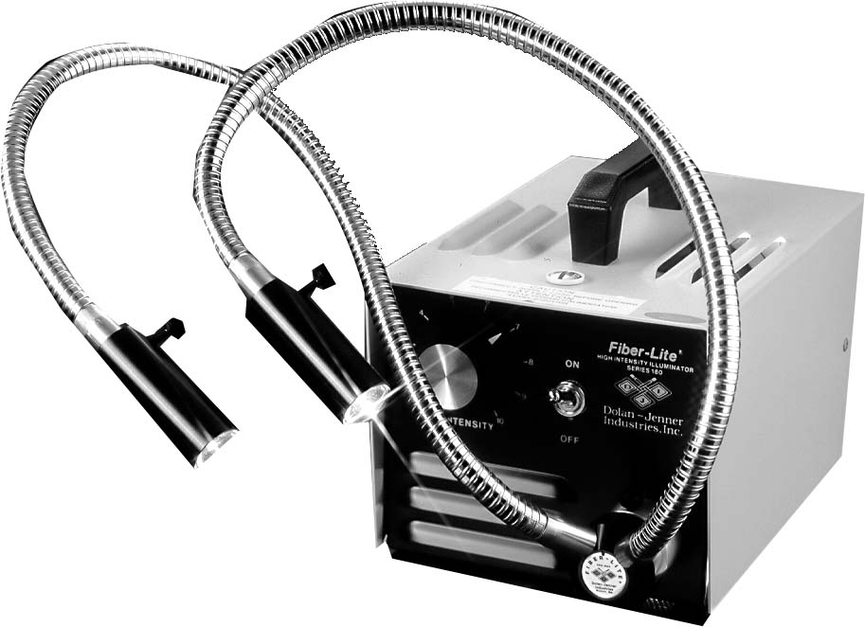
Specifications
Lamp: | EKE, 21 Volt, 150 Watt  (EJV, 21 Volt, 150 Watt, optional)
Lamp Life: | 200 Hours at full intensity (40 Hours at full intensity)
Color Temperature | EKE, 3250ºK (EJV, 3350ºK, optional)
Voltage: | 115 VAC, 50/60 Hz  220/230 VAC, 50/60 Hz
Intensity Control: | Rehoeostat, 50 - 100%
Fuse : | 2.5A 250V 3AB slow blow (115 VAC)  1.25A 250V 3AG slow blow (230 VAC)
Noise Level: | N/A
Dimensions: | 5.87" x 6.5" x 9"
Weight: | 9.00 Pounds
Fiber Input Diameter | 1.00"
Adapters | A-type adapter series

Fiber-Lite 180 Illuminator
360-1 RL System
- Durable and quiet with the lowest possible vibration levels  - Compatible with all Fiber-Light stand and custom fiber optic light guides | 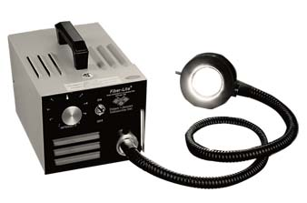
Specifications
Lamp: | EKE, 21 Volt, 150 Watt  (EJV, 21 Volt, 150 Watt, optional)
Lamp Life: | 200 Hours at full intensity (40 Hours at full intensity)
Color Temperature | EKE, 3250ºK (EJV, 3350ºK, optional)
Voltage: | 115 VAC, 50/60 Hz  220/230 VAC, 50/60 Hz
Intensity Control: | Rehoeostat, 50 - 100%
Fuse : | 2.5A 250V 3AB slow blow (115 VAC)  1.25A 250V 3AG slow blow (230 VAC)
Noise Level: | N/A
Dimensions: | 5.87" x 6.5" x 9"
Weight: | 9.00 Pounds
Fiber Input Diameter | 1.00"
Adapters | A-type adapter series

Fiber-Lite 180 Illuminator
Classic 150 Watt Illuminator
- Durable and quiet with the lowest possible vibration levels  - Compatible with all Fiber-Light standard and custom fiber optic light guides | 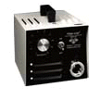
Specifications
Lamp: | EKE, 21 Volt, 150 Watt  (EJV, 21 Volt, 150 Watt, optional)
Lamp Life: | 200 Hours (40 Hours at full intensity)
Color Temperature | EKE, 3250ºK (EJV, 3350ºK, optional)
Voltage: | 115 VAC, 50/60 Hz  220/230 VAC, 50/60 Hz
Intensity Control: | Rehoeostat, 50 - 100%
Fuse : | 2.5A 250V 3AB slow blow (115 VAC)  1.25A 250V 3AG slow blow (230 VAC)
Noise Level: | N/A
Dimensions: | 5.87" x 6.5" x 9"
Weight: | 9.00 Pounds
Fiber Input Diameter | 1.00"

